
VNUHCM - University of Science
FACULTY OF INFORMATION TECHNOLOGY

Exploring My Home LAN Network
SUBJECT: INTRODUCTION TO INFORMATION TECHNOLOGY
INSTRUCTORS: Phạm Trọng Nghĩa Class: 25C01

No. | Student ID | Full name
1 | 25127113 | Võ Thiện Trí Nhân

Ho Chi Minh City - 30/11/2025

Mục lục
- Introduction 1
- Modem & Router 1
  - Basic Information . . . . . . . . . . . . . . . . . . . . . . . . . . . . . . . . . . . . . . 1
  - Ports and Buttons . . . . . . . . . . . . . . . . . . . . . . . . . . . . . . . . . . . . . . 2
- Network Configuration Analysis 2
- Network Topology Identification 3
  - Topology . . . . . . . . . . . . . . . . . . . . . . . . . . . . . . . . . . . . . . . . . . 3
  - Central device . . . . . . . . . . . . . . . . . . . . . . . . . . . . . . . . . . . . . . . . 3
  - Scalability . . . . . . . . . . . . . . . . . . . . . . . . . . . . . . . . . . . . . . . . . . 3
  - Comparison . . . . . . . . . . . . . . . . . . . . . . . . . . . . . . . . . . . . . . . . . 3
  - A Network Diagram . . . . . . . . . . . . . . . . . . . . . . . . . . . . . . . . . . . . . 3

Introduction
Besides artificial intelligence, my core professional interest also lies in computer networking, specifically focusing on the mechanisms of data transmission and the complex protocols governing inter-device communication. The physical infrastructure, including the wiring and the operational observation of how electronic devices exchange data, is a particularly compelling area of study.
This report documents the research and analysis conducted on the Local Area Network (LAN) deployed within my residence.
The residential LAN infrastructure is fundamentally simple and heavily reliant on wireless connectivity. Most client devices connect via Wi-Fi, with the notable exception of a personal computer, which utilizes a dedicated Ethernet connection to ensure optimal performance.

Modem & Router

Basic Information
    - Model: A720R
    - Manufacturer: TOTOLINK
My house only has two routers (another is hard to reach) handling the connections of the devices. No switches, access points,s repeaters are found.
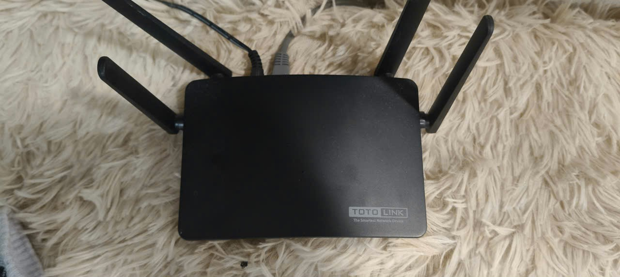

Figure 1: Main face of my router

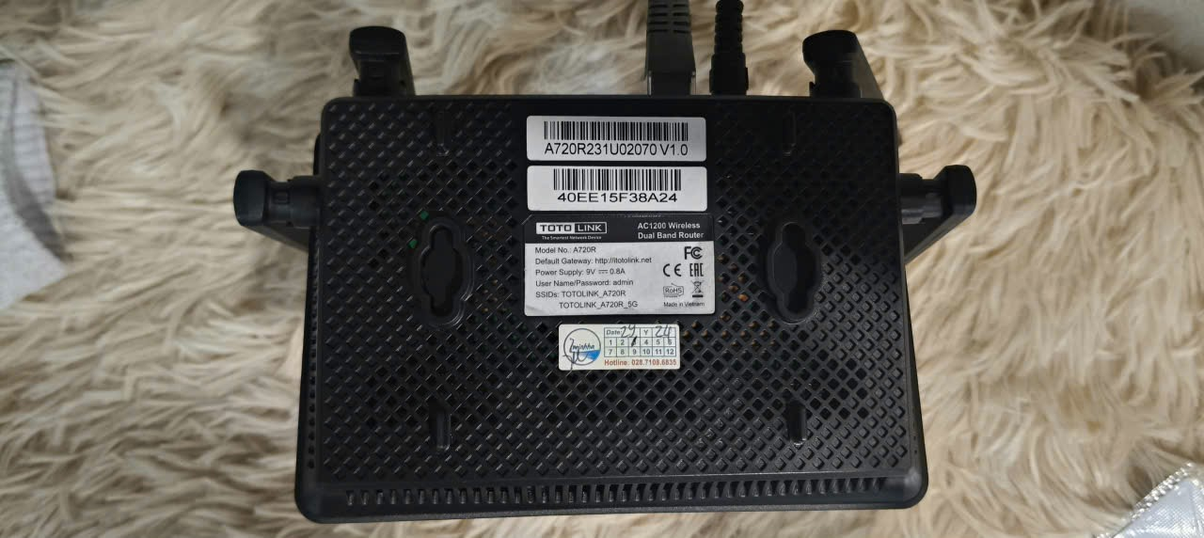

Figure 2: Back face of my router

Ports and Buttons
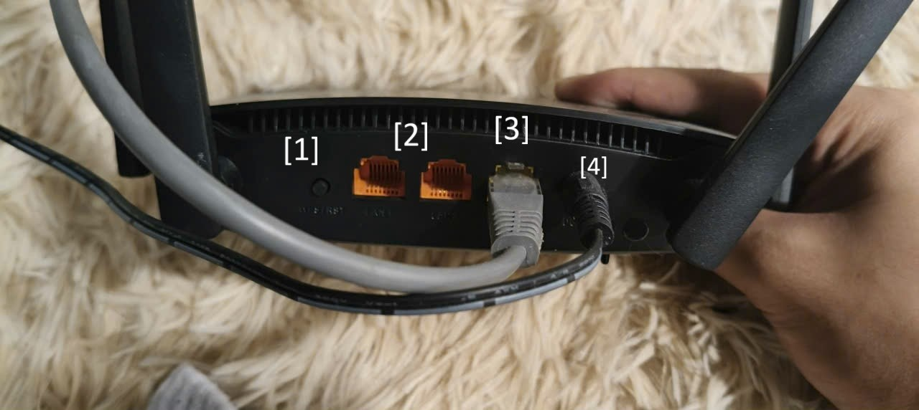

Figure 3: Ports on my router
Notations:
- : Power button
- : Ethernets
– There are 2 Ethernet ports.
- : Internet
- : AC socket

Network Configuration Analysis
- IP Address: 172.16.0.2
- Subnet Mask: 255.255.255.255
- Default Gateway: 192.168.0.1

- Physical Address: C0-D9-67-22-0E-C8
Usable IP Address range: 172.16.0.1 - 172.16.0.254.
The IP addresses are private because the addresses are private when they have 10. x.x.x, 172.16.x.x - 172.31.x.x, or 192.168.x.x. My IP address satisfies the condition, so it is private.

Network Topology Identification
The devices in my house are mainly connected through Wi-Fi, except my personal computer has an ethernet cable connecting it to the internet.

Topology
In my observation, the topology in my LAN network is Pure Star. Because every device is connected independently to the router.

Central device
The only central device that all others connect through is the router. Its role is to create a wireless LAN network so that devices like laptops, phones, and TVs can connect to the network.
If there is a problem with the router that makes it stop working, the network is interrupted. The devices cannot access the Internet due to a lost connection, except for my personal computer.

Scalability
My router is mid-range, so it can support 20-30 devices at a time. Because my router only has two Ethernet ports, my devices need to be connected through Wi-Fi, or consider buying a switch or a router to extend the number of ports.

Comparison
My setup suits my family’s usage. Every device is connected to the network independently, reducing errors and bottlenecks. Furthermore, the devices are pretty far from each other. Therefore, using Bus topology is not an optimal option.
The advantages:
    - Reducing errors and bottlenecks.
    - Optimal for far-away devices.
    - Working smoothly even if there is an interruption between a device and the router.

A Network Diagram
This is a diagram illustrating the topology of my home LAN network. In my house, 10 electronic devices are connected to the LAN network:
    - 3 phones
      - Mainly connected through Wi-Fi.
    - 1 tablet
      - Mainly connected through Wi-Fi.

    - 2 laptops
      - Mainly connected through Wi-Fi.
    - 3 televisions
      - Mainly connected through Wi-Fi.
    - 1 personal computer
      - Connected using an Ethernet cable.
